**Rice sample selection method for crop-cuts and survey (2016)**

1. For the time being limited, only Remote Sensing (RS)-based NDVI values (based on landsat images) are been taken proxy for sample selection for crop cut and survey
2. Check the distribution of NDVI in each district. The distribution is based on 30x30 m2 resolution grids from Landsat images (August last week 2016 raster). Districts may be different in terms of inputs use and cropping calendar (i.e., seeding, transplanting, irrigation, weeding, fertilizer apply/access and harvesting times) so, sampling based on NDVI distribution in each districts will be more meaningful for capturing variability. Remember that this is just a sample selection method for crop cuts and survey and not the final data. In Nepal we have decided to include 6 districts (Kanchanpur, Kailali, Bardyia, Banke, Kapilbastu & Rupendhai). We will do the sampling selection in each of the districts separately:
3. Kanchanpur district (Far-west Nepal): We want to select the samples based on the distribution of NDVI, so that selected sample will represent each quartiles of distribution.

**Steps:**

1. Check the summary statistics and distribution of NDVI

*Example (Table 1): summary statistics of NDVI in Kanchanpur district*

|  |  |  |  |  |
| --- | --- | --- | --- | --- |
| No of grids/samples | Mean | St. dev | Min | Max |
| 682818 | 0.4102598 | 0.0817195 | 0.0005267 | 0.657633 |



Fig1: distribution of coarse NDVI values in Kanchanpur district for agriculture LCP map from ICIMOD

1. Disaggregate NDVI based on Mean & St. dev and follow the “theory of normal distribution: literally” (i.e., Mean ± 3 St. dev) which will capture 99.7% of samples in bell curve while taking ± 3 std.dev and 68% while taking ± 1 St. dev range in bell curve. (For example: the range for the distribution curve in Kanchanpur district is 0.41±0.24 (i.e., 0.17 to 0.65). This can also be minimize to 2 stdev from mean for our sampling purposes so that will capture almost 95% of sample grids in distribution.



Fig2: NDVI Normal distribution curve after removing outliers

1. There might be some NDVI values in grids which may be far below and/or above the range in step (ii) but we will be explicitly focusing the sample selection based on the NDVI range as defined in step (ii). Perhaps one answer to why question to capture 95% only is; these are extreme values i.e., outliers and are very less samples are likely to fall in this range.
2. We are going to do the crop cut and survey on these grids within this range i.e., bell curve. In Nepal we have agreed to conduct the crop-cuts in 24 plots (~10-15% of survey hhs) in each district which will give a total of 144 plots crop cuts data from 6 districts and we will be using 120 households sample survey in each districts which will give 720 total household level data for inputs and other management practices. However, you may see the no of samples in each districts is more than that; its due to enumerators speed up survey in later days of survey and increased the sample size proportionally from each quartiles of bell curve.
3. We will use the same percentage sampling method based on NDVI distribution i.e., bell curve (eg., % samples in quartiles of bell curve i.e., mean ± 1stdev 68% samples and mean ±2 stdev 95% samples grids) for sample selection and crop cuts survey across the NDVI range in bell curve and the samples can be selected randomly because it is very difficult to backtrack the farms/plots if we fix at the beginning based on coordinates because of spatial heterogeneity in NDVI’s within small areas, so only possible way is to select randomly from the defined quartiles.
4. We plotted all these four types (mean+1stdev, mean-1stdev, mean+2stdev and mean-2stdev) into district level map and now we will select the samples where there is a large cluster formed for each of the quartiles/groups/types so that it will be relatively easy once we pair this 4 types of classification maps with sub-district and village names (e.g. Google earth also).

Total samples for crop-cuts and survey in **Kanchanpur** district

|  |  |  |  |  |
| --- | --- | --- | --- | --- |
| **SN** | **Range** | **No of grids/samples** | **Crop-cuts (no)** | **Survey (no)** |
| 1 | Mean + 1 stdev | 245436 | 8 | 48 |
| 2 | Mean - 1 stdev | 206836 | 8 | 48 |
| 3 | Mean + 2 stdev- first stdev | 116628 | 4 | 24 |
| 4 | Mean – 2 stdev – (- upto first stdev) | 91431 | 4 | 24 |
| 5 | Mean + 3 stdev- upto 2nd stdev | 1887 | 1 | 5 |
| 6 | Mean – 3 stdev – ( - upto 2nd stdev) | 13914 | 1 | 5 |
|  | **Total** | **676132** | **24** | **144** |

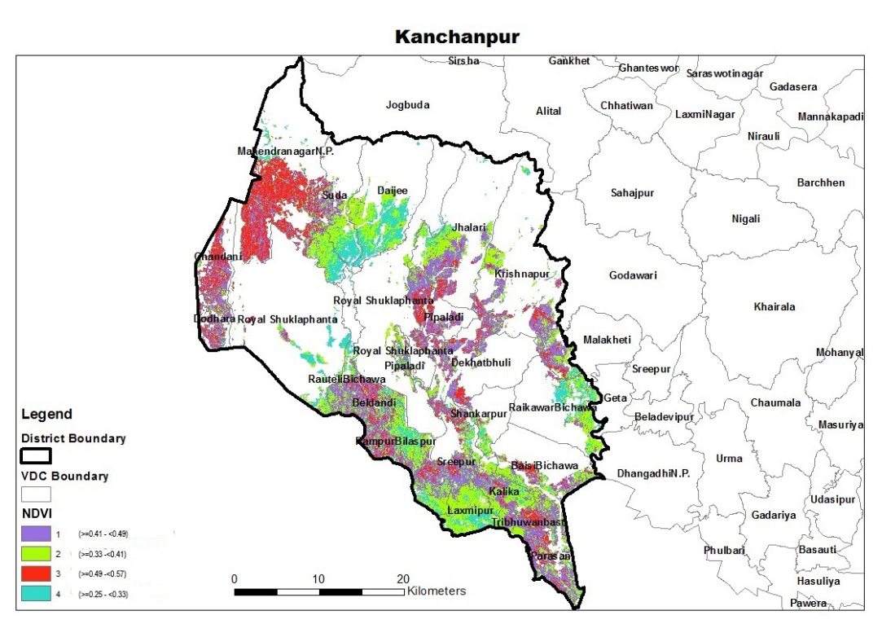

Fig 3: The distribution of NDVI based in Kainchanpur district (Far-west teari) based on NDVI classified by quartiles of bell-curve.

Example: where to focus for crop cuts and survey so that the sample selected will represent the NDVI range distribution in bell curve? Ans: There will certainly be a cluster formed somewhere in sub-district or village level and that will be the area for crop cuts and survey (see example below for Kanchanpur districts sub-district and village level map below)

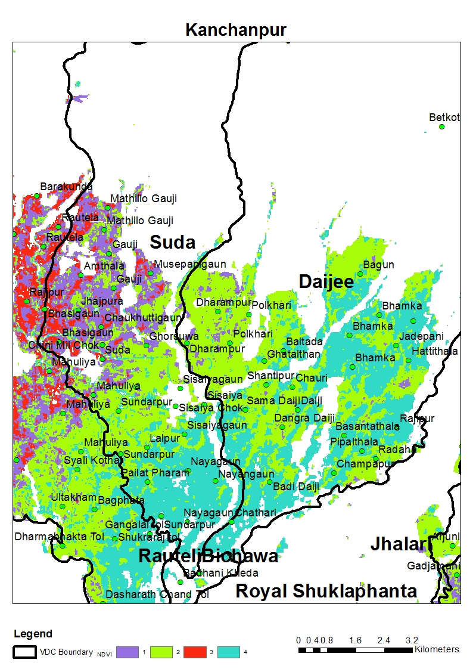

Fig 4: The distribution of NDVI that shows some clustering of groups based on four quintiles of normal distribution (we can do crop cut and survey for group 2 (green) and group 4 (light blue) here)

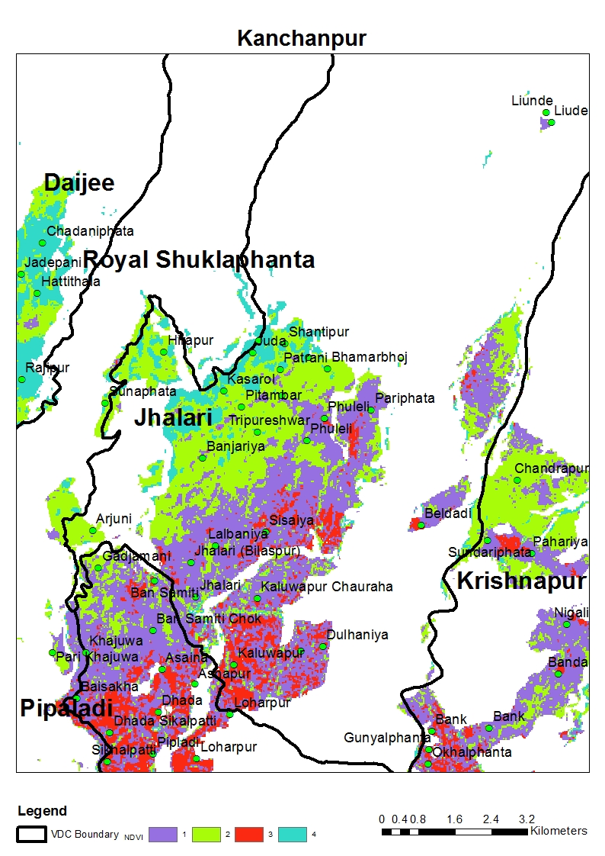

Fig 5: The distribution of NDVI that shows some clustering of groups based on four quintiles of normal distribution (we can do crop cut and survey for group 1 (purple) here)).

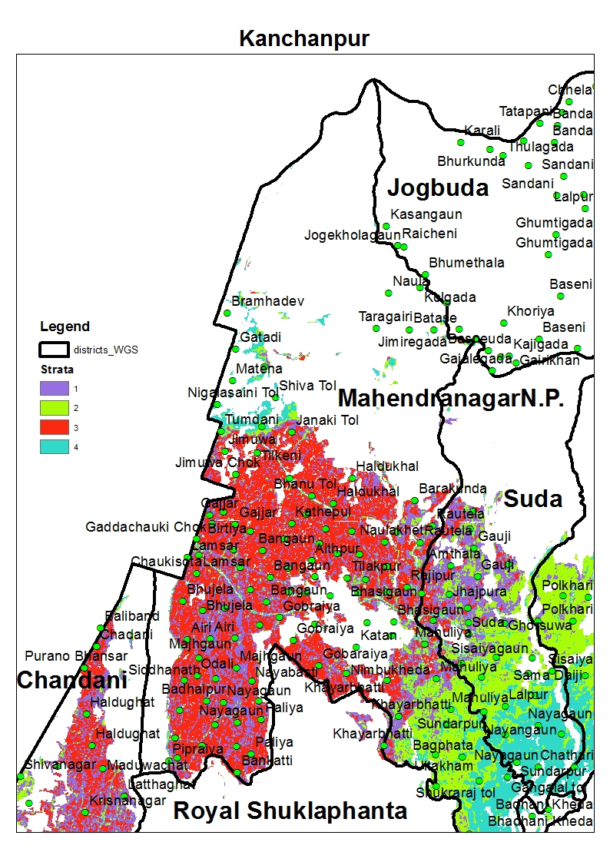

Fig 6: The distribution of NDVI that shows some clustering of groups based on four quintiles of normal distribution (we can do crop cut and survey for group 3 (Red) here)).

Similar methods for rest of other 5 districts also:

1. **Kailali** district (Far-west Nepal): Same method as above

|  |  |  |  |  |
| --- | --- | --- | --- | --- |
| **SN** | **Range** | **No of grids/samples** | **Crop-cuts (no)** | **Survey (no)** |
| 1 | Mean + 1 stdev | 495129 | 8 | 48 |
| 2 | Mean - 1 stdev | 259572 | 8 | 48 |
| 3 | Mean + 2 stdev- first stdev | 131892 | 4 | 24 |
| 4 | Mean – 2 stdev – (-first stdev) | 119714 | 4 | 24 |
| 5 | Mean + 3 stdev- upto 2nd stdev | 24607 | 1 | 5 |
| 6 | Mean – 3 stdev – ( - upto 2nd stdev) | 261 | 1 | 5 |
|  | **Total** | **1031175** | **24** | **144** |

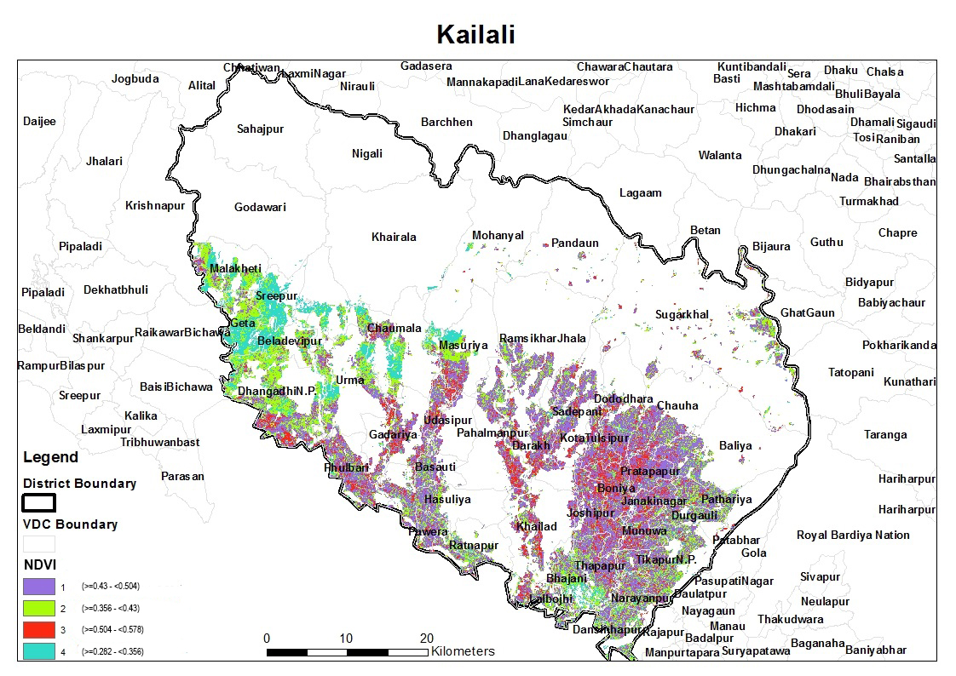

Fig 4: The distribution of NDVI based in Kailali district (Far-west teari)

1. **Bardyia** district (Mid-west Nepal):

|  |  |  |  |  |
| --- | --- | --- | --- | --- |
| **SN** | **Range** | **No of grids/samples** | **Crop-cuts (no)** | **Survey (no)** |
| 1 | Mean + 1 stdev | 203079 | 8 | 48 |
| 2 | Mean - 1 stdev | 140460 | 8 | 48 |
| 3 | Mean + 2 stdev- first stdev | 37430 | 4 | 24 |
| 4 | Mean – 2 stdev – (-first stdev) | 40659 | 4 | 24 |
| 5 | Mean + 3 stdev- upto 2nd stdev | 162 | 1 | 5 |
| 6 | Mean – 3 stdev – ( - upto 2nd stdev) | 10232 | 1 | 5 |
|  | **Total** | **432022** | **24** | **144** |

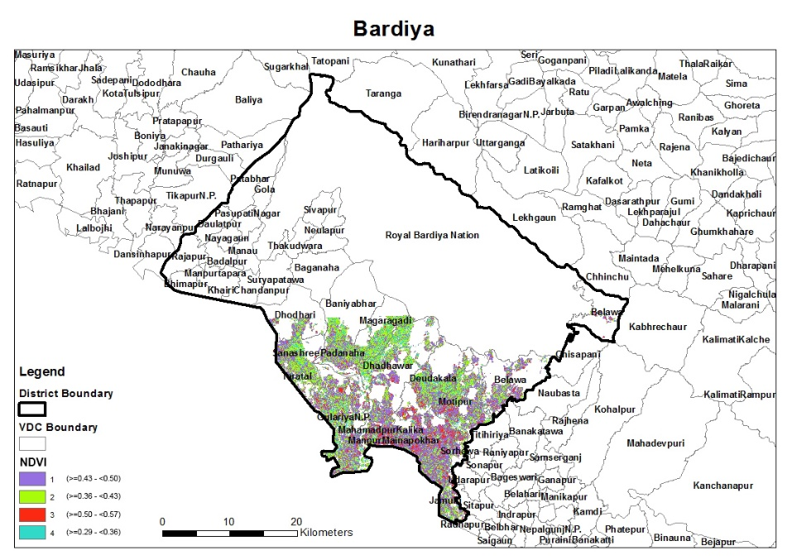

Fig 5: The distribution of NDVI based in Bardyia district (Mid-west teari)

1. **Banke** district (Mid-west Nepal):

|  |  |  |  |  |
| --- | --- | --- | --- | --- |
| **SN** | **Range** | **No of grids** | **Crop-cuts (no)** | **Survey (no)** |
| 1 | Mean + 1 stdev | 362558 | 8 | 48 |
| 2 | Mean - 1 stdev | 133746 | 8 | 48 |
| 3 | Mean + 2 stdev- first stdev | 87037 | 4 | 24 |
| 4 | Mean – 2 stdev – (-first stdev) | 74517 | 4 | 24 |
| 5 | Mean + 3 stdev- upto 2nd stdev | 37 | 1 | 5 |
| 6 | Mean – 3 stdev – ( - upto 2nd stdev) | 47593 | 1 | 5 |
|  | **Total** | **705488** | **24** | **144** |

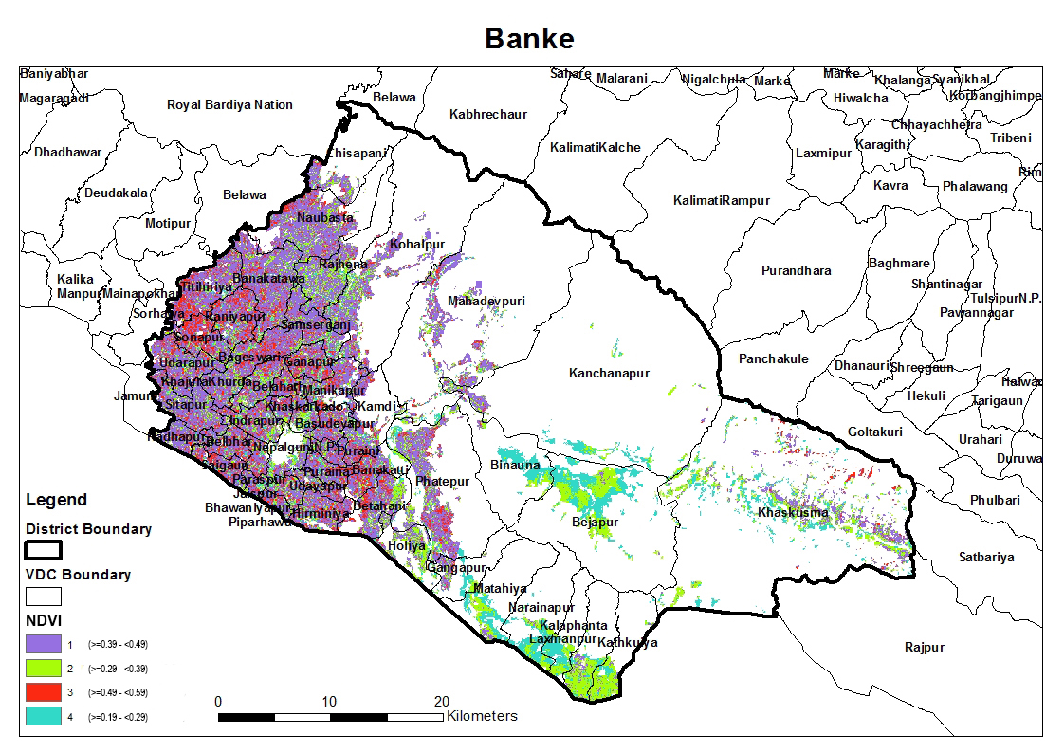

Fig 6: The distribution of NDVI based in Banke district (Mid-west teari)

1. **Kapilbastu** district (Western Nepal):

|  |  |  |  |  |
| --- | --- | --- | --- | --- |
| **SN** | **Range** | **No of grids** | **Crop-cuts (no)** | **Survey (no)** |
| 1 | Mean + 1 stdev | 593734 | 8 | 48 |
| 2 | Mean - 1 stdev | 226508 | 8 | 48 |
| 3 | Mean + 2 stdev- first stdev | 93226 | 4 | 24 |
| 4 | Mean – 2 stdev – (-first stdev) | 70004 | 4 | 24 |
| 5 | Mean + 3 stdev- upto 2nd stdev | 94 | 1 | 5 |
| 6 | Mean – 3 stdev – ( - upto 2nd stdev) | 43999 | 1 | 5 |
|  | **Total** | **1027565** | **24** | **144** |

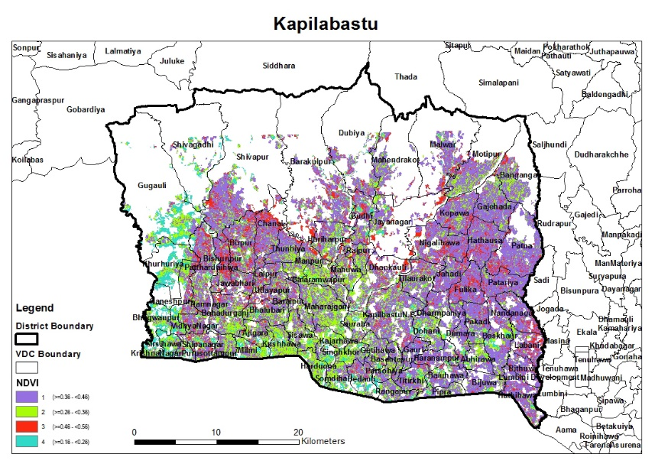

Fig 7: The distribution of NDVI based in Kapilbastu district (Mid-west teari)

1. **Rupendhai** district (Western Nepal):

|  |  |  |  |  |
| --- | --- | --- | --- | --- |
| **SN** | **Range** | **No of grids** | **Crop-cuts (no)** | **Survey (no)** |
| 1 | Mean + 1 stdev | 557620 | 8 | 48 |
| 2 | Mean - 1 stdev | 269157 | 8 | 48 |
| 3 | Mean + 2 stdev- first stdev | 95546 | 4 | 24 |
| 4 | Mean – 2 stdev – (-first stdev) | 75087 | 4 | 24 |
| 5 | Mean + 3 stdev- upto 2nd stdev | 872 | 1 | 5 |
| 6 | Mean – 3 stdev – ( - upto 2nd stdev) | 28394 | 1 | 5 |
|  | **Total** | **1026676** | **24** | **144** |

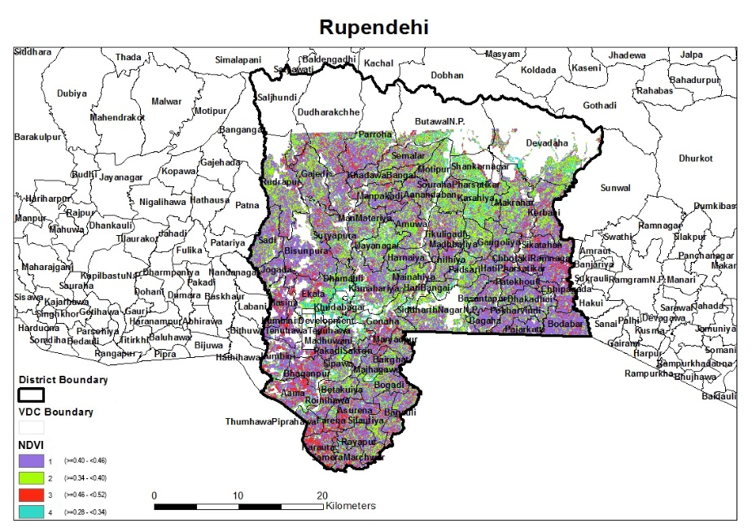

Fig 8: The distribution of NDVI based in Rupendhai district (Mid-west teari)